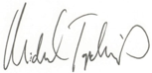

Patient Perspective

National Leader, Chartis Center for Rural Health

Top Quartile Performer Category

Bowdle Hospital

PERFORMANCE

LEADERSHIP

AWARD 2023